**TRASAT-SEMTA Modeling**

1. **Overview**

The TRASAT/SEMTA MATLAB models should include: target RCS model, target trajectory model, radar unit model, multistatic radar model, multilateration localizer algorithm, tracking algorithm, and the results visualization. TRASAT and SEMTA models are very similar but differ in some details as shown on the Figure 1.

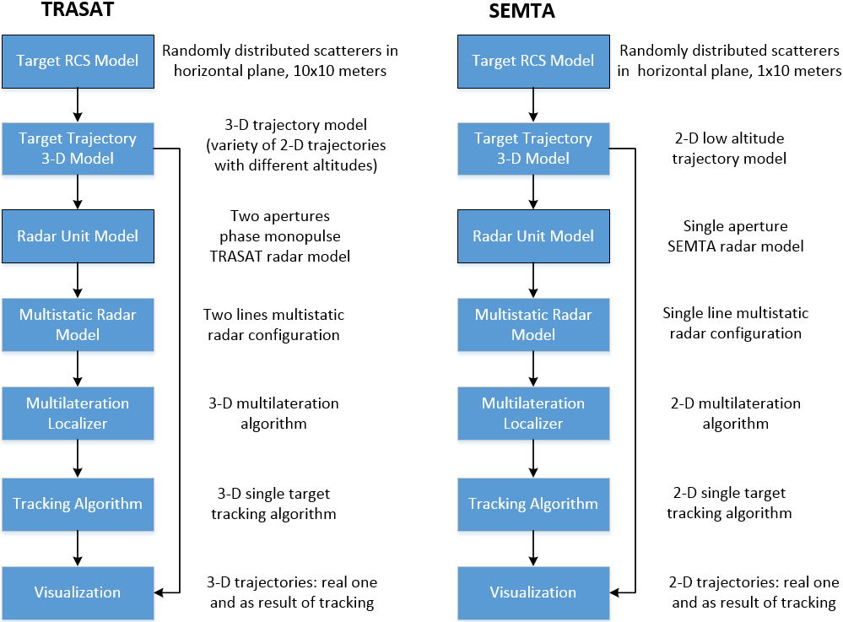

Figure 1. MATLAB Model Diagrams.

1. **Target RCS Model.**

Radar Cross Section (RCS) of the complex targets like aircraft or missile, is strongly depends from aspect angle (see Figure 2 and Figure 3 for illustration) and radar carrier frequency. Radar frequency diversity technic with combination of binary integration (m of n processing) allow to select peaks (and avoid dips) from RCS fringe for specific angular region and significantly improve probability of detection (Pd) of the targets keeping very low probability of false alarm (Pfa).

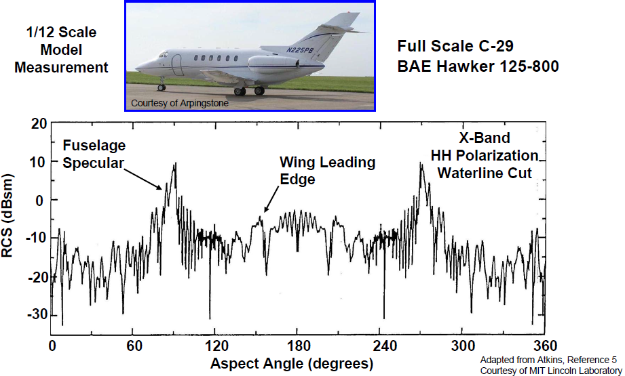

Figure 2. Measured RCS of the C-29 aircraft model. Note, the model was scale down in factor of **12**. Full size RCS of the aircraft in about **22 dB** (20log12) higher.

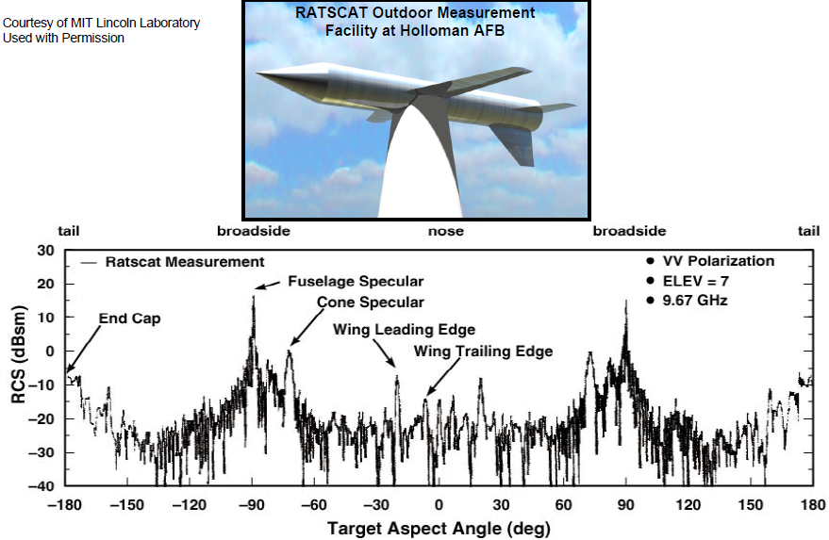

Figure 3. Measured RCS of the full-scale missile.

To build realistic fluctuated model of the target we plan to use model with randomly distributed point scatterers as shown on the Figure 4. Total size of the scattering area should be about the same as a target 2D footprint. Thus, for SEMTA missile model L1=6m and L2=3m, for TRASAT air vehicle L1=L2=10m.

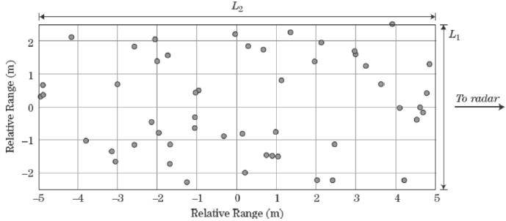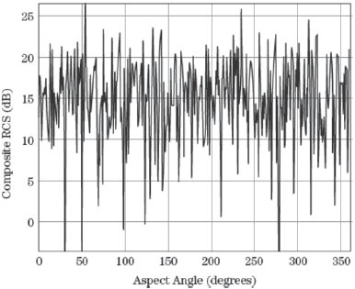

Figure 4. Complex target modelling with multiple randomly distributed scatterers.

We are going to calculate the target RCS as function of aspect angle and carrier frequency. The aspect angle resolution (∆Θ) will be at least 0.1 degree and carrier frequency resolution ∆F=10 MHz. The calculation results should be multiplied on some coefficient to get average RCS value equal to expected target RCS. It would be nominally 0dBsm for TRASAT air vehicle, and -20dBsm for SEMTA missile.

1. **Target Trajectory Model.**

Target trajectory is function of 3-D Cartesian (x, y, and z) coordinates and time, where x is excursion from central flight line, y corresponds central flight direction, and z is altitude of the target. See Figure 5 and Figure 6 for illustration. Fixed altitude values ($z_{i}$) and constant linear velocity along with y coordinate ($v_{y}$) may be assumed for simplicity. Nominal $z_{i}$ values are 30 meters for SEMTA, and from 100 to 6,000 meters for TRASAT. Nominal $v_{y}$ values are 400 m/s for SEMTA and 200 m/s for TRASAT. Our simplified target trajectory model uses only x-coordinate as non-linear movement component. The sinusoidal x(t) behavior looks acceptable for the target trajectory simulation.

With the above assumptions, trajectory may describe by following equations:

$x\left(t\right)=d×\sin\left(at\right)$, where d is varied from 0 (straight flight) to 3,700 meters (+/- 2 nmi excursion), and a=2π/t is period of the trajectory excursion, a-value would be normally from 0.05 to 0.2.

$y\left(t\right)=v_{y}t$, where $v_{y}$ is target velocity projection on y-coordinate.

z= $z_{i}$

1. **Radar Unit Model.**

Preliminary plan for pulse repetition interval/frequency (PRI/PRF) selection for TRASAT and SEMTA radar units provide unambiguous range capability up to 7nmi. But Doppler ambiguity is hard to avoid on radar unit level without radar sensitivity sacrifice. Thus, applying two or more PRI cycles to resolve the ambiguity requires reducing of the CPI (coherent processing interval) length in two (or more) times. Instead the multi PRI technic for single radar, we plan to resolve the Doppler ambiguity by using data from multiple (at least two) radars in the TRASAT/SEMTA center processing.

Radar unit model include several consequent operations:

1. Signal and noise calculation in single coherent processing interval (CPI) cycle
2. Non-coherent integration
3. Threshold selection and target detection
4. Binary integration, or m of n processing
5. Monopulse processing

**Radar unit SNR** is calculated by using basic radar equation for pulse-Doppler radar and discrete target:

(4π)3

Where is transmit power during the pulse, $G_{t}\left(Θ_{h},Θ_{v}\right) and G_{r}(Θ_{h},Θ_{v})$ are gain of the transmit and receive antennas consequently as function of the angle $Θ_{h} and Θ_{v}$ which are incident angles in horizontal and vertical planes relatively to antenna boresight, $τ_{p}$ is pulse length, $λ$ is RF wavelength, $σ$ is target RCS, $n_{p}$ is number of pulse in CPI, R is range to the target, k = 1.38 x 10-23 is Boltzmann constant, T=290K is standard temperature, NF – noise figure of the radar receiver, and $L_{r}$– radar total losses.

For MATLAB model radar signal and noise will be calculated separately. Energy of the signal at the radar receiver input during single CPI cycle is equal to:

(4π)3

where is target RCS for different frequency carrier (F) and aspect angle (Θ) as explained above (see Target RCS Model section).

Antenna gain as function of the incident angles considers the gain decreasing if incident angle differs from boresight position. SEMTA and TRASAT radars have electronically beam steering and monopulse capabilities in horizontal direction, which allow point the radar beam to the direction of the target. However, the antenna gain is still proportional to cos $Θ_{h}$ as the cosine factor characterize antenna projection to the incident wave direction. For SEMTA radar operation, gimbal mechanism is going to adjust antenna vertical position to the horizon. TRASAT radar has also vertical monopulse functionality, which allow to adjust radar vertical beam angle to target direction by using the mechanical gimbal. Wide vertical angle (about 20 degree) of the TRASAT radar allow very rough (+/-5 degree) accuracy of the mechanical tuning. Thus, for both SEMTA and TRASAT radars we can use following expressions for antenna gain:

$G_{t}\left(Θ_{h},0\right)=G_{t}\left(0,0\right)cosΘ_{h}$, and $G_{r}\left(Θ_{h},0\right)=G_{r}\left(0,0\right)cosΘ_{h}$

Where, $G_{t}\left(0,0\right) and G_{r}(0,0$) are transmit and receive antenna gain in the boresight direction.

Radar receiver noise will be simulated in MATLAB by using Monte Carlo algorithm. Root mean value (RMS) of the noise should be equal to $kT×NF$.

Table below contains all the parameters for TRASAT and SEMTA radar units in accordance of our preliminary design. In differ of SEMTA, TRASAT has two receive antennas, which can be used either for monopulse operation or for Pd improvement.

|  |  |  |  |  |  |  |  |  |  |
| --- | --- | --- | --- | --- | --- | --- | --- | --- | --- |
|  | $$P_{t}$$ | $$G_{t}(0,0)$$ | $$G_{r}(0,0)$$ | $$τ_{p}$$ | $$λ$$ | $$σ$$ | $$n_{p}$$ | NF | $$L_{r}$$ |
| TRASAT | 64W | 23 dBi | 23 dBi | 20 µs | 0.032 m | 0dBm2 | 512 | 3 dB | 4 dB |
| SEMTA | 64W | 27 dBi | 27 dBi | 20 µs | 0.032 m | -20 dBm2 | 512 | 3 dB | 4 dB |

RCS ( $σ)$ values shown in the table corresponds average RCS of the fluctuated target as discussed in Target RCS Model section.

**Non-coherent integration** is applied for TRASAT if target altitude exceeds 1 km (as preliminary estimated). In this case, the target altitude can be accurately determined with multilateration algorithm and vertical monopulse is not required. To utilize effectively two of the receive antennas, signals from them should be integrated non-coherently, which increase radar sensitivity.

**Threshold selection and target detection** is fulfilled for each CPI cycle with the multiple CPI train. The threshold level should be about 10 dB over the noise level. The relatively low threshold cannot provide good Pd and Pfa statistic for single CPI basic. Multiple of false detection due to noise only may happens.

Further non-coherent processing will filter out the false detections.

**Binary integration, or m of n processing** allow significantly reduce Pfa and improve Pd rates. The processing proves the detections if at least m threshold crossing from n tries occurs in the specific range and Doppler area. Preliminary, we plan to use 2 of 10 version of the binary integration, but we are going to play with different m and n numbers and threshold levels in our model and probably will apply different binary integration set. To overcome negative effect of the target fluctuation, frequency diversity technic will be applied. To make the technic effective and decorrelate different CPI cycles, frequency shift (ΔF) should be higher than c/2L2, where L2 is target depth as viewed along radar line of sight. Thus, for L=3m (as estimated for SEMTA target), ΔF should be at least 50 MHz. High speed velocity of the TRASAT and especially SEMTA targets provide also RCS decorrelation due to aspect angle (Θ) changing. Min ΔΘ for the target RCS decorrelation is equal to λ/2L1, where L1 is target width as viewed along radar line of sight.

Because target range value can vary for different CPI cycles in binary integration frame, the range interval for m of n processing should be increased to accommodate the possible range changing.

In radar unit binary integration processing, all over the threshold Doppler bins may be combined for each range bin. Since its possible option, this approach results in Pfa increasing. We will consider alternative methods for target association in the ambiguous Doppler scale to reduce the Pfa.

**Monopulse processing** forTRASAT system is alternative method of the target altitude determination. As the major approach for the altitude measurement is based on multilateration algorithm, the monopulse can provide higher accuracy for low altitudes of the target while multilateration error is going up. We plan to compare accuracy of the methods for different radar configurations and target altitudes to get better understanding how the methods combination can improve the TRASAT system performance.

Phase difference of the received signal in phase comparison monopulse antenna is equal to ∆φ = 2π(d/λ)sinΘ, where d is distance between antenna sections phase centers and Θ is angle between incident angle and antenna boresight. If d = 5λ, as planned for TRASAT, the ∆φ = 10πsinΘ. Large separation between antennas provides us high radar sensitivity to the incident angle, but with expense of ambiguous characteristic if the incident angle is varied in wide range. We plan to apply multilateration algorithm to resolve the monopulse ambiguity. Unambiguous incident angular range is laid between -0.1 rad and 0.1 rad, or approximately +/-6 degree. In the range,

Θ = sin-1(λ∆φ/2πd),

Target altitude (h) is equal to h = Rsin(Θ+ Θ0), where R is range to the target and Θ0 is antenna boresight angle relatively to horizon. Since, the Θ0 value depends on USV platform roll position and antenna gimbal position, both angles (or its sum) should measured with high accuracy. We plan to provide 0.1-degree accuracy of angles determination by using high tilt sensors.

1. **Multistatic Radar Model**.

Multistatic radar configurations for SEMTA and TRASAT are illustrated on Figure 5 and Figure 6.

Since, sea-skimming target tracking for SEMTA is not required the target altitude determination, single row multistatic arrangement is applicable for the 2-D target positioning system. Although two-rows configuration may be reasonable to make wider the test corridor for SEMTA application, doubling of the number of USV with the radar units doesn’t look as good excuse for this solution. We consider applying single row radar unit array to minimize total system cost and complicity. With accordance of our preliminary estimations, the USV with radar units should be in 2nmi apart each other. We will define other radar configuration parameters, such as min and max ranges for different target RCS, with the MATLAB simulation model.

In the other side, TRASAT system must provide 3-D position determination for air vehicle flying as high as 6,000 meters. Two-rows radar units’ arrangement for TRASAT allows the 3-D target positioning with radar and multilateral algorithm. To keep number of USV with the radar installed as low one unit per 2nmi of the test corridor length the distance between adjacent radar in each row will be 4nmi or about. The test corridor width (difference between max and min ranges) should be about 4nmi. The MATLAB model allow us to optimize the radar configuration and confirm feasibility of the TRASAT approach.

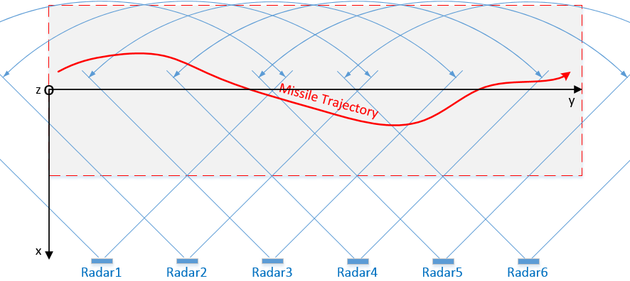

Figure 5. SEMTA Multistatic Radar Configuration.

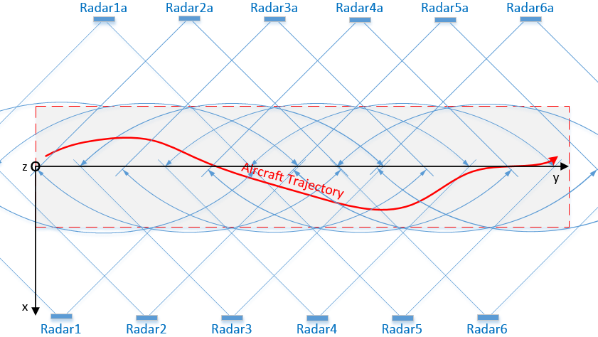

Figure 6. TRASAT Multistatic Radar Configuration.

1. **Multilateration Localizer**

For **2-D Multilateration (SEMTA)** radar array,the following approach allow to determine target position in general case:

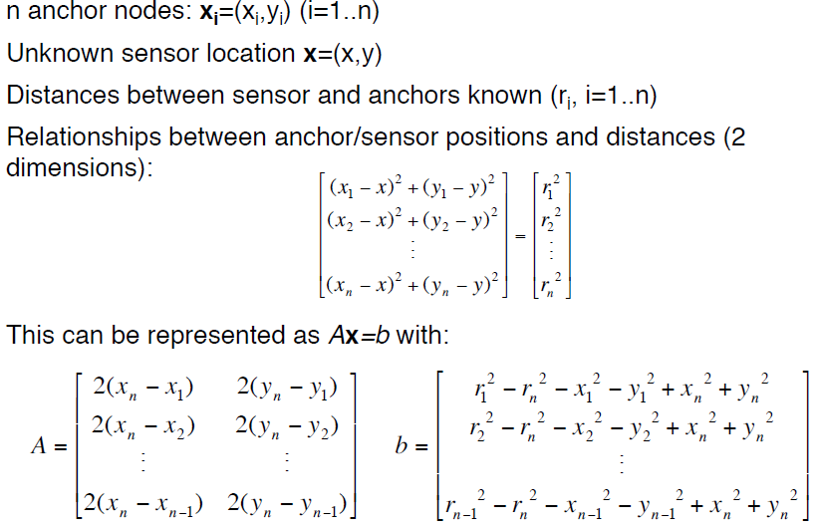

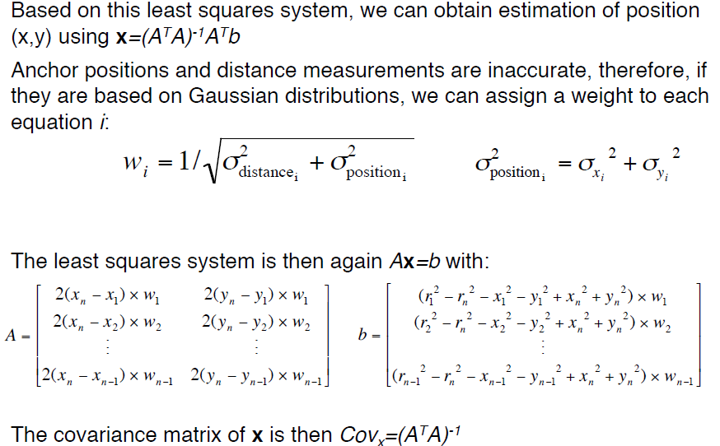

The expressions may be simplified with assumption that max 2 radars units can obtain target range information. In this case, only one solution for target coordinates can be calculated and least square method for position estimation is not required. We can use this assumption in our model. If more than two radars can detect target and measure the range, only two results can be selected based on max SNR basis.

Similar formulas as above may be applied for **3-D Multilateration (TRASAT)**. Only third, z-coordinate should be added to the expression. The similar simplification as for 2-D can be applied for 3-D system. It’s required limitation of the number of resulted radars by number of 3, with at least one of the radar unit on each multistatic row.

1. **Tracking Algorithm**

The calculated target coordinates and velocity data will be used for single target tracking algorithm. The tracking will be based on predictor-corrector algorithm of the Kalman filter. Nearly constant velocity target motion model will be considered. The Kalman filter parameters will be determine during simulation.